``

**كلية العلوم الحاسوبية والمعلوماتية**

Faculty of CSI

**LifeAssist**

*Students:*

|  |  |
| --- | --- |
| Dalaa Yaser Saqer | 202210366 |
| Toleen Malek Al-shattel | 202210551 |
| Sara Nabeel Abuodeh | 202210418 |

*Supervisor:*

Dr. Alaa abuthouabeh

*Amman - Jordan*

*2024/2025*

**Table of Contents**

1.1 Problem Statement and project Scope page 1

1.2 Project Plan and Schedule

2. System Analysis page 2

2.1 Functional Requirements

2.2 Use Case Diagram

3. System Design page 3

3.1 Class Diagram

3.2 ER-Diagram (if a database will be used)

3.3 User Interface

* 1. Problem Statement and project Scope

The system has been facing problems due to its paper-based appointment

system. With the increase in the number of patients visiting, it has

become diﬃcult to manage the appointment system manually. Recording

of appointments and creating registers by pen and paper has become a

Access to reliable medical equipment is a significant challenge for individuals, caregivers, and healthcare providers.

Many patients recovering at home or managing chronic conditions require essential health products like oxygen concentrators, hospital beds, or wheelchairs, The project involves developing an online platform dedicated to the sale and rental of medical equipment to address the identified challenges.

This scope defines the foundation for a comprehensive solution to make medical equipment accessible, affordable, and convenient.

Gantt Chart:

Figure 1: Gantt Chart of project

* 1. Functional Requirements

1.User Management

1.1. The system must allow users to register for an account with basic details (name, email, phone number, address).

2. Product Catalog

2.1. The website must display a categorized list of medical equipment available for sale and rent.

2.2. Each product must have a detailed description, specifications, pricing (purchase and rental), and high-resolution images.

3. Customer Support

3.1. A live chat feature must be available for users to ask questions or request assistance.

3.2. FAQs and product guides must be accessible to address common queries.

4. Reviews and Ratings

4.1. Users must be able to leave reviews and ratings for purchased or rented products.

4.2. The system must display average ratings and reviews on product pages to guide future customers.

5. Rental Management

5.1 The system must allow users to choose rental periods (daily, weekly, or monthly) and display corresponding prices.

5.2. A notification system must remind users of upcoming rental expirations and provide options to extend the rental period.

6. Shopping Cart and Checkout

6.1. Users must be able to add products to a shopping cart with options for both purchase and rental.

6.2. the system must support editing the cart (e.g., changing quantities, removing items, or adjusting rental durations).

2.2 Use Case Diagram

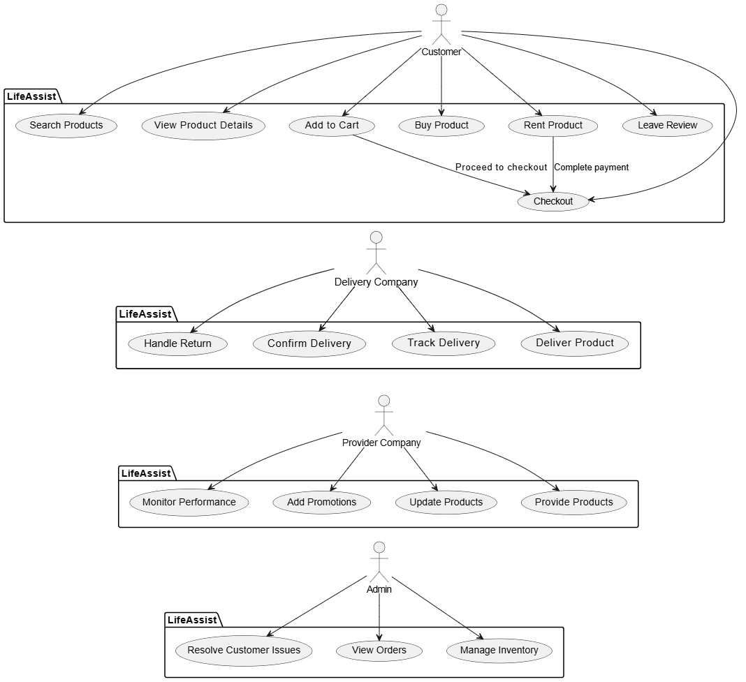

Figure 2: Use Case diagram of system

3. System Design

3.1 Class Diagram

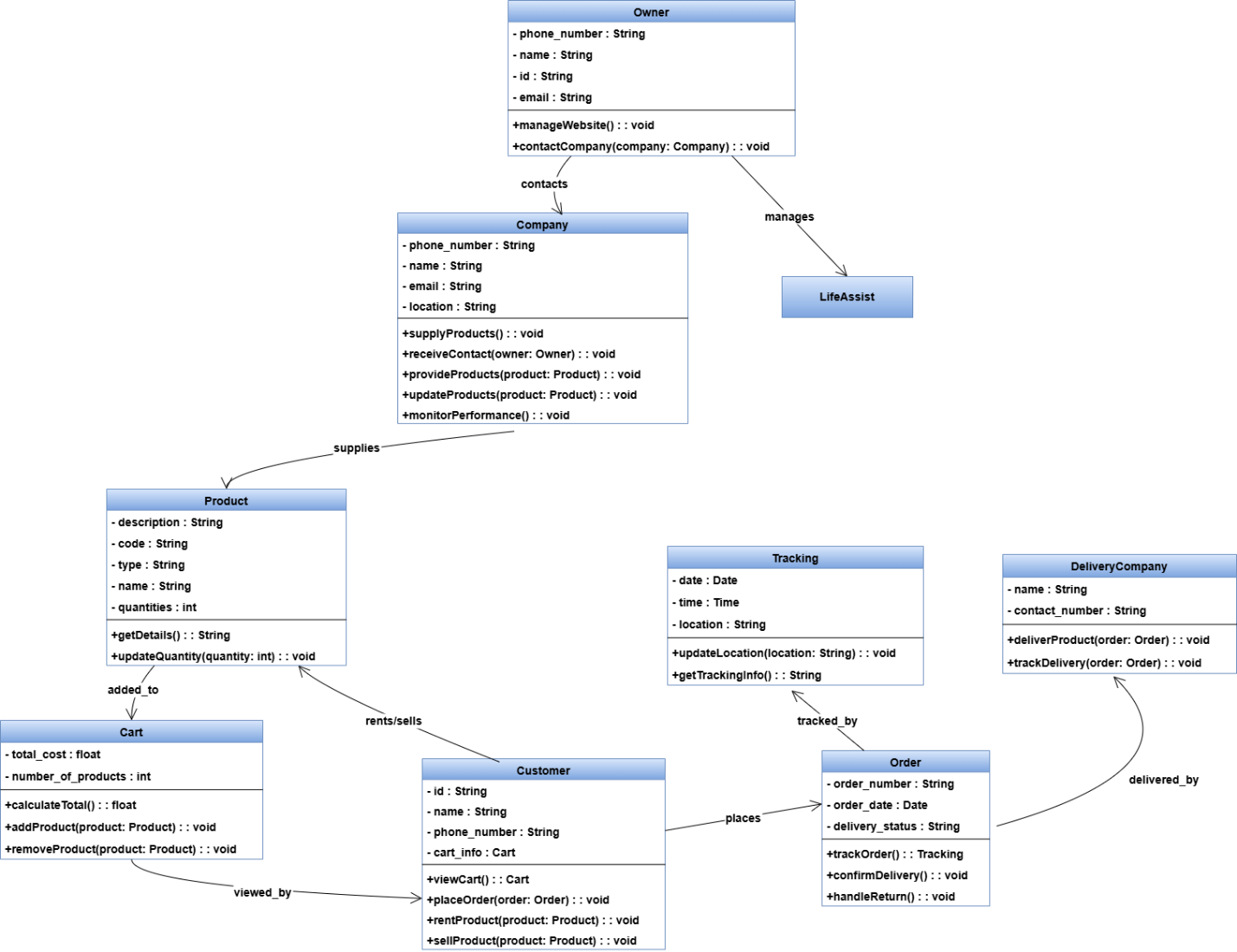

Figure 3: Class diagram of Appointment system

3.2 ER-Diagram

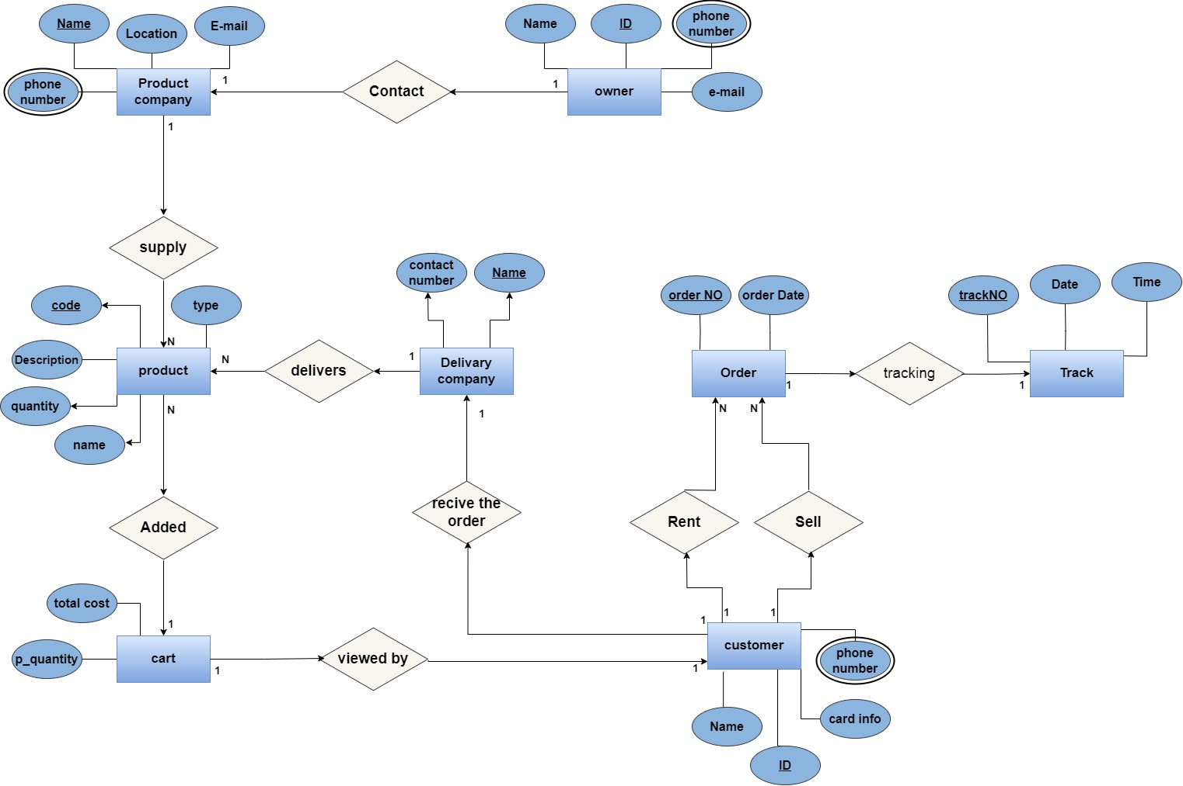

Figure 4: ER diagram of Appointment system

3.3 User Interface

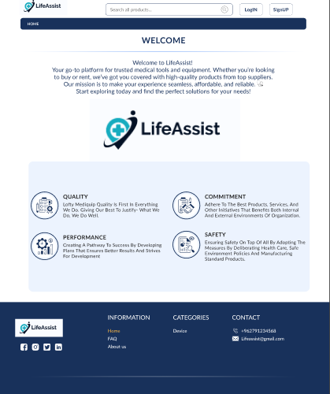

Figure 5: Main UI of Appointment system



